C U R R I C U L U M V I T A E
P e r s o n a l D e t a i l s

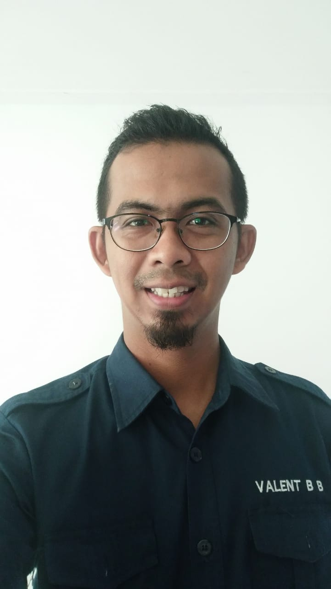
Name | : | Valentino Butar-butar
Home Address | : | Jl. Kutilang Blok DD1 No. 14 Pondok Pekayon Indah
Phone / Mobile | : | 0856.120.1010
Place / Date of Birth | : | Jakarta, July 30th 1985
Sex | : | Male
Religion | : | Moslem
Marital Status | : | Merried
Nationality | : | Indonesian

E d u c a t i o n a l B a c k g r o u n d ( F o r m a l)

T r a i n i n g & C o u r s e (Non. Formal)

Educational Background |  | Institutions & Status | Years
University / Institute | : | STIKOM INTERSTUDI  Communication Faculty – Public Relations  (Graduate) | 2003 - 2011
Senior High  School | : | SMU Tunas Jakasampurna – Bekasi (Graduate) | 2000 - 2003
Junior High  School | : | SMPN 12 Bekasi – Bekasi (Graduate) | 1997 - 2000
Elementary School | : | SDN Nusa Indah – Bekasi (Graduate) | 1991 - 1997

Spesifications | Institutions | Years
General English | LIA, bekasi | 2001
Futsal School | Adjie Massaid Futsal Clinic | 2005
Coaching clinic | Mizone Futsal Coacing Clinic | 2006
Seminar Nasional Cyber PR | Hotel Sahid Jakarta | 2008

Computer / PC ;  Software Application | Microsoft Office (Ms.Word, Ms.Excel, Ms.Powerpoint, Ms.Outlook)  Photoshop
Event Organizer Management | Production, General Affair
S K I L L

W o r k i n g E x p e r i e n c e

Company | Fuctional Posisitions | Years
PT. Cemerlang Tunggal Intikarsa (CTI) | - Branch Office Manager  - SPV Database  - Carnival Cruise Line Cordinator  - Windstar Cruise Line Cordinator  - Recruitment Staff Dept.  - NCL Cordinator  - Windstar Cruies Line Cordinator  - Guest Service | Sep 16, 2013 – Present
Bank Victoria | Account Officer Development Program  (Marketing Dept.) | Oct 01, 2012 – July 31, 2013
PT. BCA Finance | Credit Marketing Officer  (Marketing Dept.) | Mei 2011 – April 2012
PT. Karya Elang Mandiri  (Event Organizer) | Production Staff  (Production Dept.) | 2010
PT. Nestle | Promotion Staff (sampling)  (Promotion Dept.) | 2008

2009

1.) Bobo Fair ‘Young Journalist’, Kompas-Gramedia & JCC 1-5 Juli 2009

2010

1.) Retro Auto & Parts Auction, Blacksteer-FX, 31 Oktober 2010
2.) Sampling & Selling, Nestle mall to mall Bekasi – Jakarta 2010

P r o j e c t s / E v e n t s / A c t i v a t i o n s

Thanks & Regards,

Valentino Bb

